To create a folder:
Right click on the Lib folder>>New>>Package
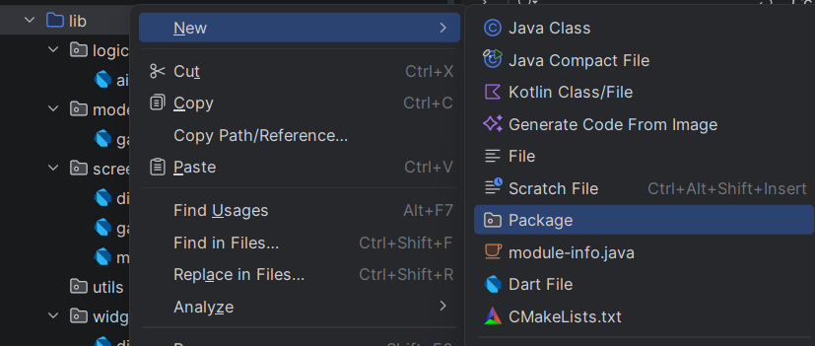

To add a new dart file:
Right click on the respective folder and click New>>Dart file
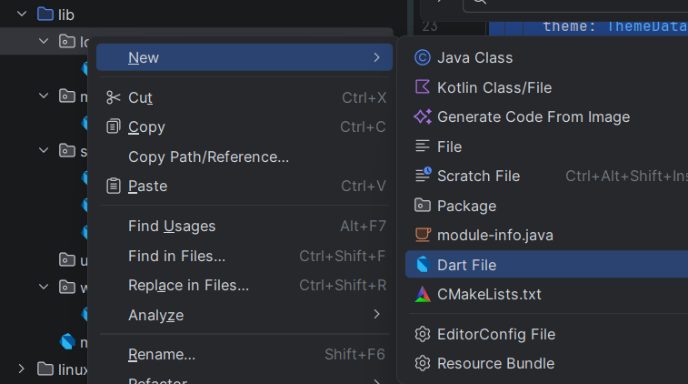

To add Confetti Package (Package needs to be added for Sparkles) in android studio:
Go to pubspec.yaml file as below
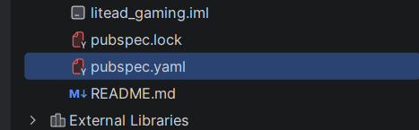

Add the below package code: with correct indentation as shown below
dependencies:
flutter:
sdk: flutter
confetti: ^0.8.0
